Long Division- Notes
How do we do a long division sum?
Does – Divide (first 2 digits)
McDonald’s – Multiply (in your rough work column)
Sell – Subtract (your answer in your multiplication sum from the first 2 digits)
Cheese – Check (is your answer from the subtraction smaller than the divisor)
Burgers – Bring down
Raw? – Remainder or Repeat the process again.
Example 1: no remainder  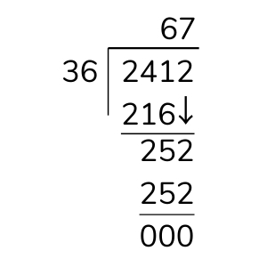 | Example 2: with a remainder

- Don’t forget to do your rough work in your rough work column on the same page.
- In Example 1, there was no remainder, you aren’t finished the sum until you get 0 in your last answer.
- If you are doing a sum like Example 2, once you get to the end, if the number you are dividing by (the divisor) does not divide in to the number, then you have a remainder.
- 3 is the remainder because 17 cannot divide in to 3.
Long Multiplication - Notes
- Long multiplication is a method of multiplying two numbers which are difficult to multiply easily.
- Example: 756 x 32 = ?
- We use long multiplication here because we are multiplying
756 by 2 digits (numbers)
- 32 is made up of 3 tens (which makes 30) and 2 units.
- We always start our sum by multiplying by the units first.

Many – Multiply by the units
Zoos - Put down the Magic Zero ( 0 )
Many – Multiply by the tens
Animals – Add your two answers together!
Let’s begin our sum!
Step 1: Multiply 756 by 2, and put your answer on the first line.
Step 2: Put down our magic ‘0’. We do this because we are going to be multiplying by the tens. Instead of trying to multiply by 30, when we put down our ‘0’, we just have to multiply by 3!
Step 3: Multiple 756 by 3, and put your answer on the second line beside the magic ‘0’.
Step 4: Add your answers together!
