St. Patrick’s Junior N.S.
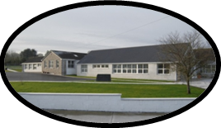
Drangan, Thurles, Co. Tipperary.
Roll Number: 19879 G
Telephone: 052-9152278
Principal – Bernie Fitzgerald
Pupils of First Class Teacher: Ms. M. Walsh
List required for September 2023
- 3 plastic envelope type folders
- 1 ruler
- Tin Whistle in the key of D
- 1 homework pack zip folder B4 size

All School books and copies will be purchased by the school and distributed to pupils in school on August 30th.

- Uniforms, bags, lunch boxes etc should be labelled clearly.
- One large t-shirt for Art Activities – labelled clearly

The Parents Association of St. Patrick’s N.S. has very kindly offered to buy pencils, toppers, rubbers and colours (crayons/colouring pencils) for each child in the Junior School. These pencils etc will be kept in school (parents will need own supply for home). Please note that children do not need a pencil case for school for September.

Art & craft materials, photocopying = €15 per child
This will be due in September and a link to Way 2 Pay will be sent to you on our return to school.
Swimming
First Class and Second Class pupils will start a seven week swimming programme on Tuesday September 12th.
The cost per child will be €60. The Parents Association will subsidise the cost of transport.

